INFO 7290 (DWBI): HW04a - SSIS

Smit Patil

1. DDL to create table for Our World in Data(OWID) dataset

CREATE TABLE owid_covid_data

(

iso_code VARCHAR(255),

continent VARCHAR(255),

[location] VARCHAR(255),

[date] DATE,

total_cases INT,

new_cases INT,

new_cases_smoothed FLOAT,

total_deaths INT,

new_deaths INT,

new_deaths_smoothed FLOAT,

total_cases_per_million FLOAT,

new_cases_per_million FLOAT,

new_cases_smoothed_per_million FLOAT,

total_deaths_per_million FLOAT,

new_deaths_per_million FLOAT,

new_deaths_smoothed_per_million FLOAT,

total_tests INT,

new_tests INT,

new_tests_smoothed FLOAT,

total_tests_per_thousand FLOAT,

new_tests_per_thousand FLOAT,

new_tests_smoothed_per_thousand FLOAT,

tests_per_case FLOAT,

positive_rate FLOAT,

tests_units VARCHAR(255),

stringency_index FLOAT,

[population] BIGINT,

population_density FLOAT,

median_age FLOAT,

aged_65_older FLOAT,

aged_70_older FLOAT,

gdp_per_capita FLOAT,

extreme_poverty FLOAT,

cardiovasc_death_rate FLOAT,

diabetes_prevalence FLOAT,

female_smokers FLOAT,

male_smokers FLOAT,

handwashing_facilities FLOAT,

hospital_beds_per_thousand FLOAT,

life_expectancy FLOAT,

human_development_index FLOAT

);

1. DML to verify all the tables are populated in the table

SELECT * FROM owid_covid_data;

1. Screenshot of SSMS displaying the populated table

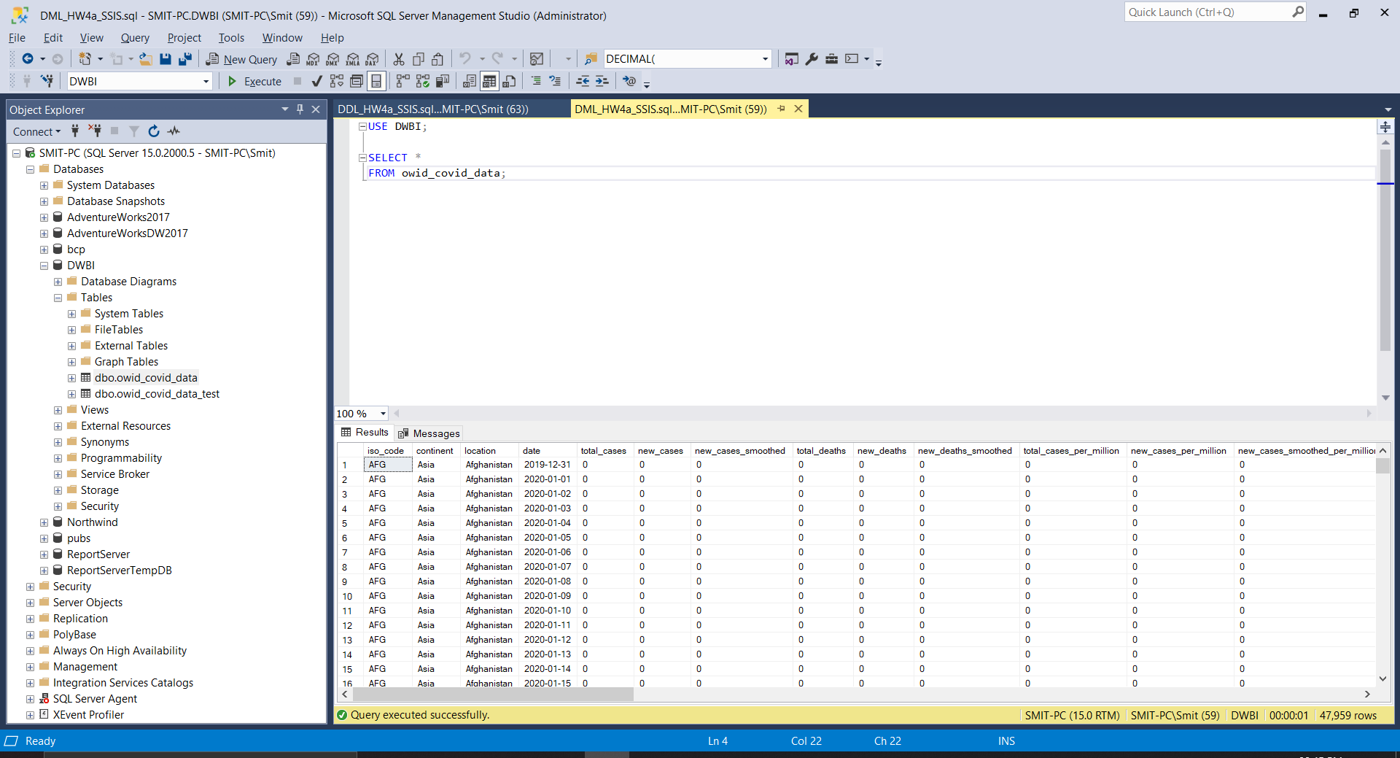

1. Screenshot of Visual Studio(SSIS) working successfully

